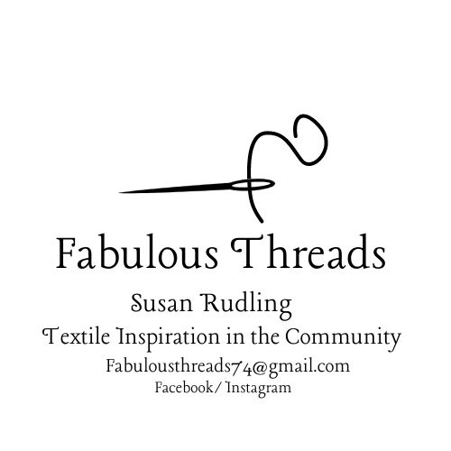
Hello and Welcome to Fabulous Threads.
Fabulousthreads74@gmail.com
Facebook/Instagram

Thank you So much for getting in touch. I love meeting and working with people in the community, where new friendships are made.

Fabulous Threads is all about Crafting with textiles in mind and the environment around us, Making crafting sustainable and great for our own well-being. Connecting back to nature.
More information about myself can be found on my website.
www.fibre-artist-susan-rudling.co.uk

Buxton Lodge, Catton Park

This Autumn I am excited to be setting up Forest School for adults. Why should children have all the fun. Take a walk in the park, and take inspiration for your textile session at Buxton Lodge.
Session will include Rust dying, Eco printing, Paper making, Hand Embroidery, Fabric dying with Plants. Textile Art, And more textiles.
Spaces are limited to 20 per session.
Materials are provided

To secure your place I ask that you pay for each session upfront. This just help to cover cost of materials.
You do not need to attend every session, and you can dip in or out, but if you don’t use it, you lose it.
You can pay before the session through pay pal, I can send you a secure payment link. Pay £12 per session or pay for the month, depending on how many session are planned for the month. If paying for the month upfront, I can offer a 10% discount.

The Parsonage, GT Ellingham, Attleborough.

Set in A Beautiful old School house. Join other fellow crafters in a set of creative sessions, designed to ignite your imagination.
If you want to make it a complete get away then you can make it stay over in Sandra's Bed and breakfast attached to the studio.
Space is limited to 10

5 Week postcard Sessions or one off textile sessions.
To secure your space please book and pay in advance. 10% discount if you book more then 4 session.

Laurence House Studio, Attleborough
These are one of sessions, No disabled access and is on the 2nd floor Only 10 spaces.

The Studio Above, Acle
STBC
Autumn Schedule 2024

Date | Classes | Cost | Location
September  3rd, 10th, 17th, 24th | Creative Textiles, Adult Forest School | £12 per session.  10% discount if block book. | Buxton Lodge, Catton Park.
September  9th 16th,23rd, 30th | Textile Postcards | £25 per session.  10% discount if you book all 4 session. | The Parsonage, GT Ellingham, Attleborough.
October  1st, 8th, 15th, 22nd 29th | Creative Textiles.  Adult Forest School | £12 per session. 10% if you block book. | Buxton Lodge. Catton park.
October  12th | Eco printing | £65 | Laurence House Studio. Attleborough.
October  14th | Needle Felted Mushrooms | £25 | The Parsonage. GT Ellingham, Attleborough.
November  2nd. | Needle Felted Mushrooms | £25 | Laurence House Studio. Attleborough.
November  4th | Macramé Xmas Baubles | £25 | The Parsonage. GT Ellingham, Attleborough.
November  5th, 19th, 26th, | Creative Textiles.  Adult Forest School | £12 per session. 10% if you block book. | Buxton Lodge, Catton Park
November  30th | Macramé  Xmas Baubles | £25 | Laurence House Studio. Attleborough
December  3rd, 10th, 17th, | Creative Textiles. Adult Forest School | £12 per session. 10% if you block book. | Buxton Lodge, Catton Park

To secure your space, please pay in advance. You do not have to do all the session.
10% discount if you book more then 4 sessions.

Payment through Pay pal.

